1 – PASSPORT MANAGEMENT SYSTEM

1-USE CASE DIAGRAM:

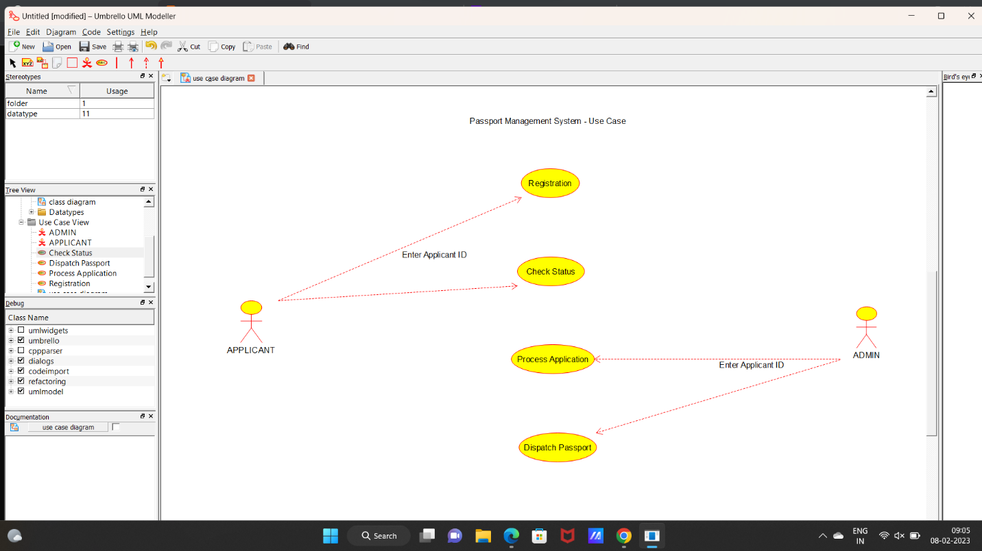

2 – ACTIVITY DIAGRAM

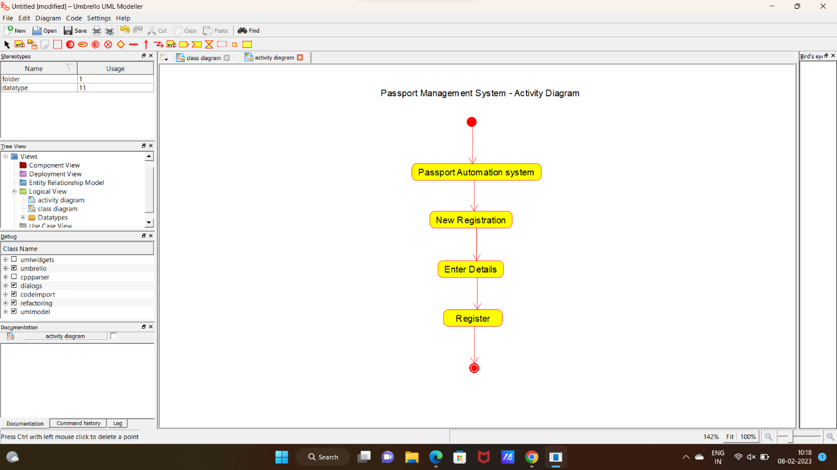

3 – SEQUENCE DIAGRAM

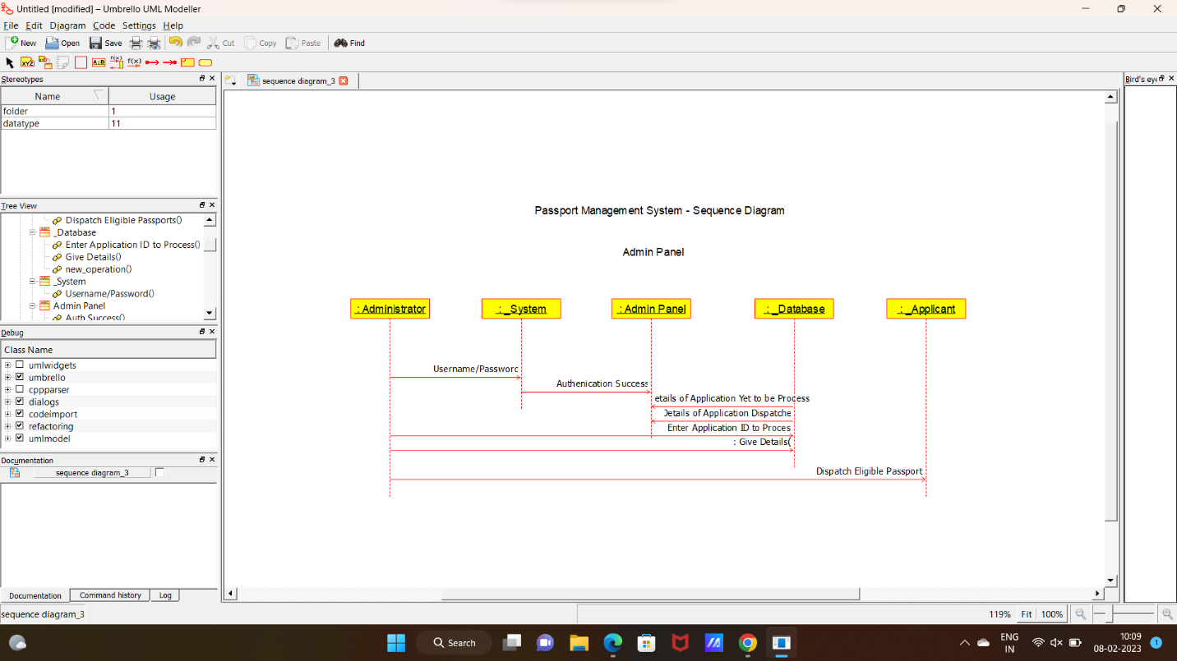

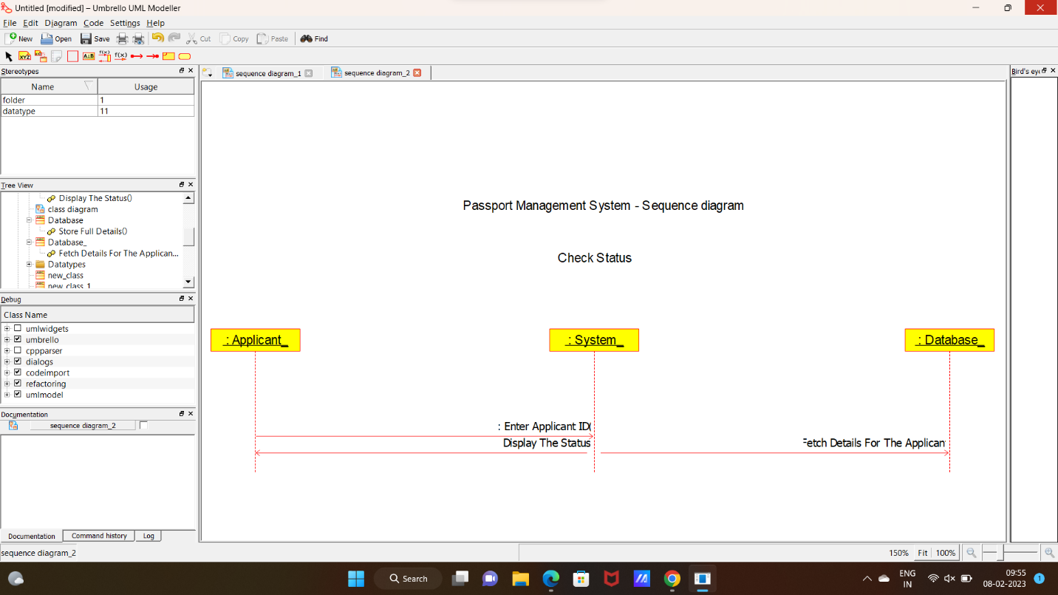

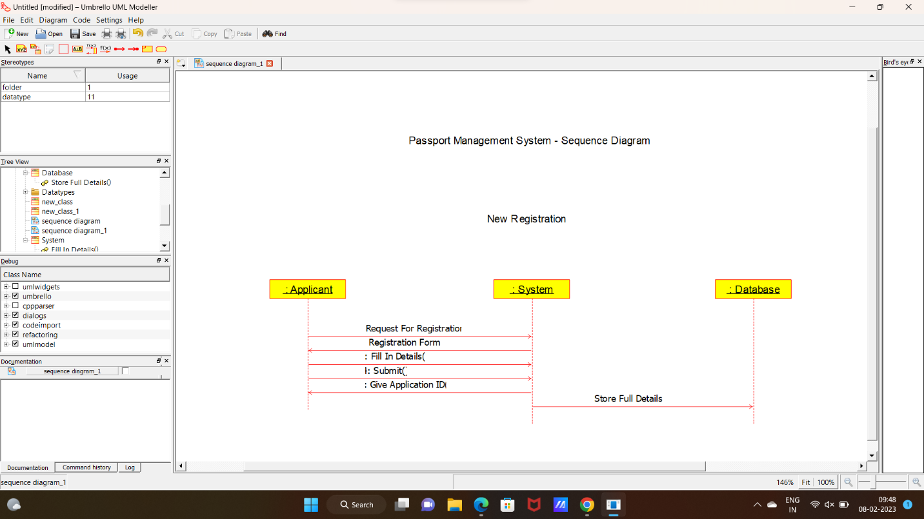

4 – CLASS DIAGRAM

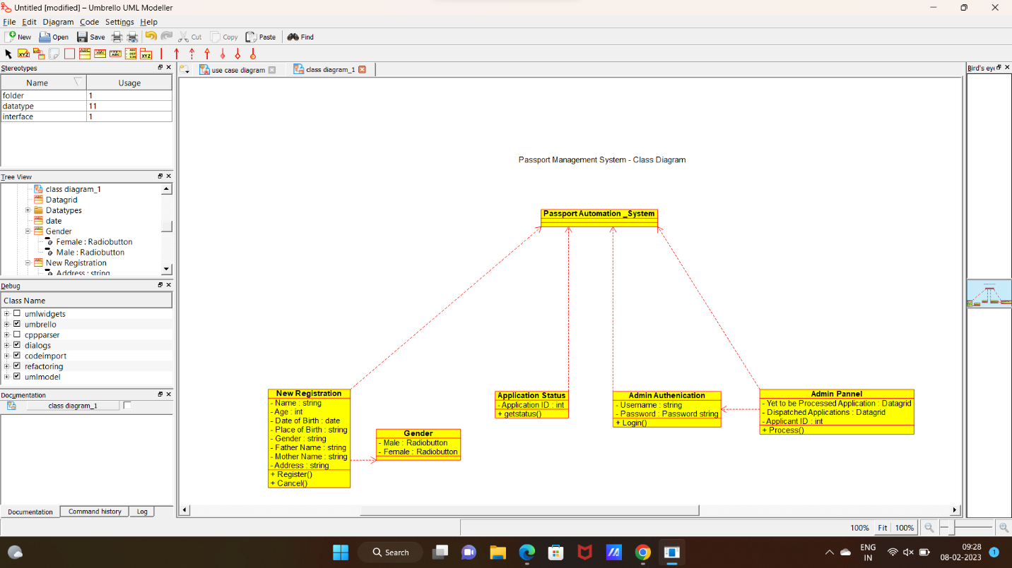

**CODE:**

**ADMIN AUTHENICATION**

#include "Admin_Authenication.h"

// Constructors/Destructors

//

Admin_Authenication::Admin_Authenication () {

initAttributes();

}

Admin_Authenication::~Admin_Authenication () { }

//

// Methods

//

// Accessor methods

//

// Other methods

//

void Admin_Authenication::initAttributes () {

}

**ADMIN PANNEL**

#include "Admin_Pannel.h"

// Constructors/Destructors

//

Admin_Pannel::Admin_Pannel () {

initAttributes();

}

Admin_Pannel::~Admin_Pannel () { }

//

// Methods

//

// Accessor methods

//

// Other methods

//

void Admin_Pannel::initAttributes () {

}

**APPLICANT**

#include "Applicant.h"

// Constructors/Destructors

//

Applicant::Applicant () {

}

Applicant::~Applicant () { }

//

// Methods

//

// Accessor methods

//

// Other methods

//

#include "Application_Status.h"

// Constructors/Destructors

//

Application_Status::Application_Status () {

initAttributes();

}

**APPLICATION** **STATUS**

Application_Status::~Application_Status () { }

//

// Methods

//

// Accessor methods

//

// Other methods

//

void Application_Status::initAttributes () {

}

#include "Database.h"

// Constructors/Destructors

//

**DATABASE**

Database::Database () {

}

Database::~Database () { }

//

// Methods

//

// Accessor methods

//

// Other methods

//